
Generative Models vs Traditional AI-Driven Anomaly Detection in Large-Scale System Logs – A Comparative Study
Thesis Report

June 25, 2026
Fall 2024 Air University
Muhammad Asad Mahmood Khan Roll # 243260 MSAI-4

Abstract
Abstract—The increasing complexity of distributed systems such as Hadoop (HDFS), Spark, and OpenStack has rendered manual log monitoring obsolete. This research proposes a comprehensive comparative study evaluating Traditional Machine Learning (ML), Deep Learning (DL), and Generative AI models for the automated detection of system anomalies within large-scale log collections. Initial benchmarking reveals that traditional supervised algorithms achieve high precision on structured data but rely heavily on labor-intensive manual feature engineering and demonstrate poor adaptability when applied to different system architectures. Furthermore, traditional unsupervised methods like Isolation Forest have shown significantly lower efficacy, highlighting a critical gap in detecting unknown errors. The primary objective of this thesis is to transcend these limitations by validating Generative Deep Learning architectures. This study aims to prove that Generative AI provides a superior balance of automation and accuracy, capable of maintaining robust performance across heterogeneous environments without the extensive manual feature engineering required by traditional ML approaches.
Index Terms—Generative Models, Traditional AI-Driven Anomaly Detection, Large-Scale System Logs.

TABLE OF CONTENTS
I. Introduction
A. Problem Statement
B. Objectives and Research Questions
II. Literature Review
A. Traditional Machine Learning
B. Deep Learning Sequence Models
C. Generative & Transformer Models
D. Research Gap
III. Methodology
A. Phase 1: Multi-Source Dataset Collection
B. Phase 2: Log Preprocessing & Parsing
C. Phase 3: Comparative Model Training
D. Phase 4: Cross-Platform Testing
E. Phase 5: Comparative Analysis & Final Evaluation
IV. Results & Analysis
- A. Baseline Performance (HDFS v1)
    - Traditional Machine Learning Results
    - Deep Learning (Supervised) Results
    - Generative AI Results
    - Comparative Analysis Synthesis (HDFS)
- B. Spark Logs Analysi
    - Machine Learning Results
    - Deep Learning Results
    - Generative AI Results
    - Spark Comparative Analysis Synthesis
- C. Hadoop Logs Analysis
    - Traditional Machine Learning Log
    - Deep Learning (LSTM and CNN
    - Generative AI (VAE and GAN)
    - Hadoop Comparative Analysis Synthesis
- D. Overall Performance Synthesis (Spark vs. Hadoop)
V. Conclusion & Future Work
- A. Conclusion
- B. Future Work
VI. References

I. INTRODUCTION
System logs serve as the primary source of truth for diagnosing failures in cloud infrastructure. In distributed environments, a single user request triggers execution traces across thousands of nodes, generating massive volumes of unstructured data. As systems scale, the variety and volume of these logs make manual rule-based detection impossible.
A. Problem Statement
Current industry standards for log analysis face a functional dichotomy.
- Brittleness of Supervised ML: Traditional models like SVM and XGBoost offer high accuracy but are fundamentally brittle. They require rigid, manual feature extraction that fails catastrophically when log syntax changes or when deployed across diverse systems.
- Inefficacy of Unsupervised Baselines: Unsupervised methods struggle to capture complex sequential dependencies, resulting in poor detection rates for unknown error patterns.
There is a critical lack of a unified framework that combines the high accuracy of supervised learning with the flexibility of unsupervised discovery.
B. Objectives and Research Questions
This research aims to benchmark traditional supervised and unsupervised models on the HDFS, Hadoop and Spark datasets to establish a baseline for known error detection. It evaluates discriminative Deep Learning (DL) sequence models for anomaly detection without manual feature extraction, and validates Generative AI architectures to determine their superiority in detecting unknown anomalies and their performance consistency across distinct platform datasets. Ultimately, it conducts a tri-fold comparative study producing a definitive performance matrix comparing ML, DL, and Generative AI.
The core research questions are:
- RQ1: To what extent can Generative AI architectures maintain consistent anomaly detection performance across distinct, heterogeneous distributed systems (e.g., evaluated independently on HDFS and Spark) compared to Traditional Supervised models?
- RQ2: Can Generative Deep Learning models eliminate the dependency on manual feature engineering required by traditional AI, while maintaining high F1-scores?
RQ3: Can deep generative models significantly outperform traditional unsupervised baselines in detecting unknown 'zero-day' anomaly patterns?
II. LITERATURE REVIEW
A. Traditional Machine Learning
Foundational studies demonstrated that supervised methods like Decision Trees and SVMs can achieve high accuracy on structured logs. However, these approaches depend entirely on parsing logs into fixed templates and manually constructing Event Count Matrices. While accurate for specific datasets, they lack portability.
B. Deep Learning Sequence Models
To reduce manual effort, approaches like DeepLog and LogRobust applied LSTMs to model logs as natural language sequences. These models achieved high F1-scores by learning sequential patterns, reducing the need for manual feature engineering but still often requiring task-specific tuning.
C. Generative & Transformer Models
Recent advancements leverage Transformers and Generative Pre-training to understand the deep semantic context of logs. These models achieve near-perfect F1-scores on benchmarks but are computationally expensive.
D. Research Gap
Despite these advancements, a critical gap remains in evaluating consistent performance across distinct systems. Most existing studies benchmark models on a single dataset in isolation. There is limited comparative research that rigorously tests these models across multiple, separate system datasets (like HDFS, Spark, and OpenStack) to determine if Generative AI consistently outperforms Traditional ML across the board without relying on manual feature extraction.
III. METHODOLOGY
This section outlines the five-phase comparative study methodology used to evaluate Traditional ML, Deep Learning, and Generative AI for log anomaly detection. 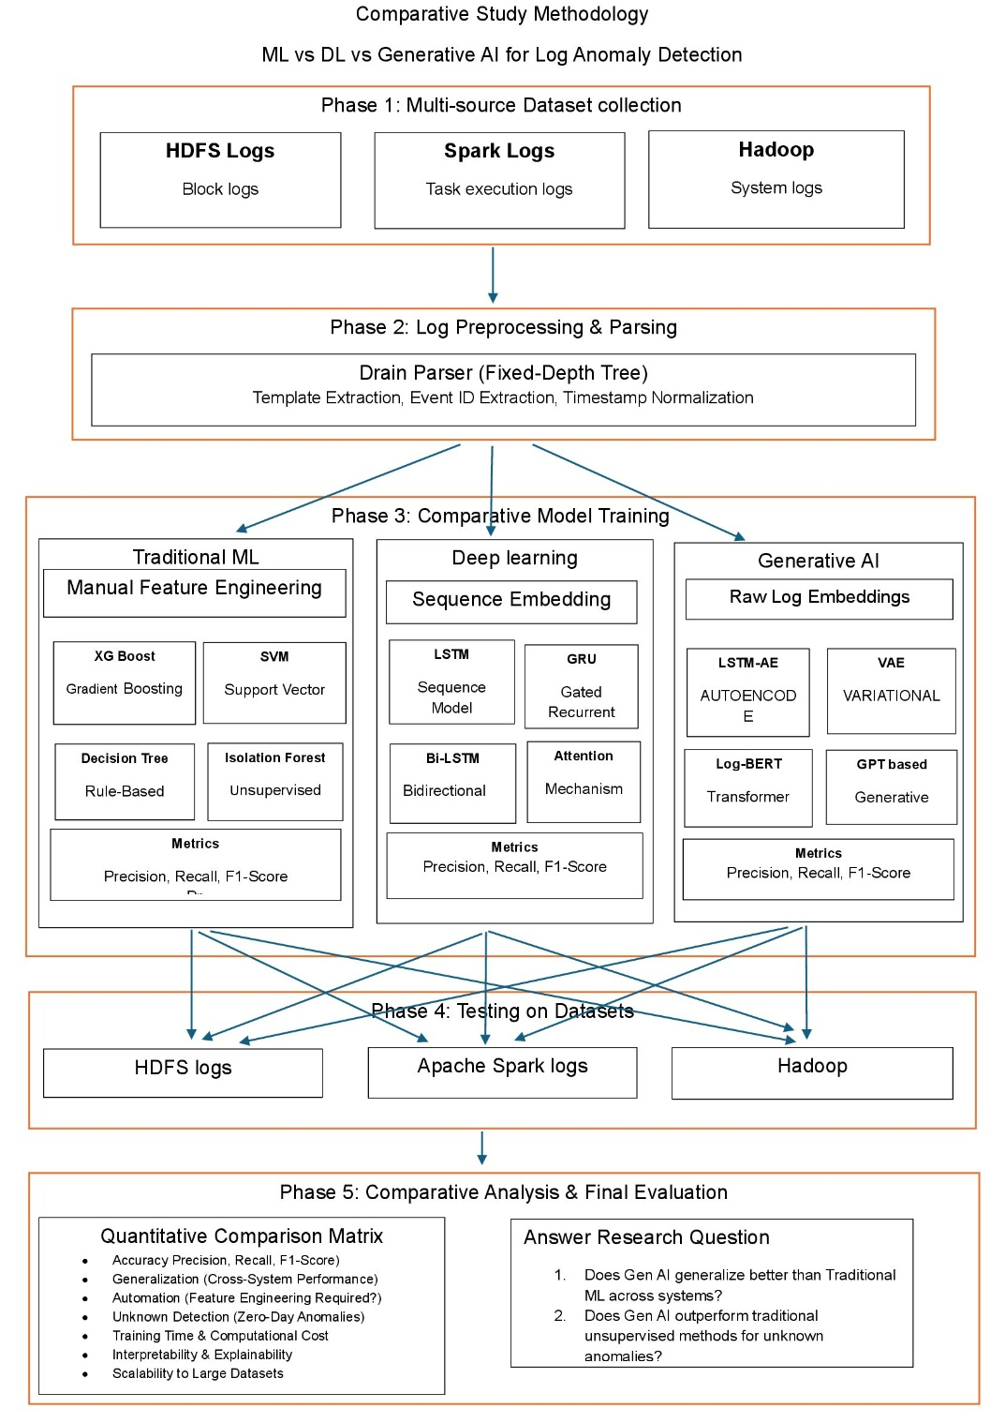
A. Phase 1: Multi-Source Dataset Collection
A multi-source repository is utilized to ensure rigorous comparative testing across heterogeneous environments:
- HDFS Logs: Collection of block logs.
- Apache Spark Logs: Collection of task execution logs.
- Hadoop & OpenStack: Collection of system logs.
B. Phase 2: Log Preprocessing & Parsing
Raw logs are processed using the Drain Parser, a Fixed-Depth Tree approach. The preprocessing involves template extraction, event ID extraction, and timestamp normalization.
C. Phase 3: Comparative Model Training
The study implements three parallel pipelines:
- Pipeline 1: Traditional ML: Relies on manual feature engineering. Models include Support Vector (SVM), Gradient Boosting (XGBoost), Rule-Based (Decision Tree), and Unsupervised (Isolation Forest).
- Pipeline 2: Deep Learning: Utilizes sequence embedding. Models incorporate Attention Mechanisms, Bidirectional Bi-LSTM, Gated Recurrent GRU, and Sequence Model LSTM.
- Pipeline 3: Generative AI: Leverages raw, self-supervised log embeddings. Models evaluated include GPT-based Generative, Log-BERT Transformer, Variational VAE, and LSTM-AE Autoencoder.
D. Phase 4: Cross-Platform Testing
To thoroughly assess model efficacy, each trained model is tested on the holdout test set (e.g., using an 80/20 train-test split) of its respective source dataset. This independent evaluation is conducted across the HDFS, Apache Spark, and Hadoop/OpenStack log collections to verify consistent performance across distinct system environments.
E. Phase 5: Comparative Analysis & Final Evaluation
Models are assessed using a Quantitative Comparison Matrix focusing on metrics such as Precision, Recall, and F1-Score. The evaluation also measures Performance Consistency (evaluation across individual system datasets), Automation (feature engineering requirements), Unknown Detection (zero-day anomalies), Training Time, Interpretability, and Scalability to large datasets. This matrix will directly answer the core research questions regarding Generative AI's capability to maintain high performance across systems and outperform traditional unsupervised methods.
IV. RESULTS & ANALYSIS
A. Baseline Performance (HDFS v1)
This section documents the comprehensive benchmarking phase evaluating Traditional Machine Learning, Deep Learning, and Generative AI pipelines. Models were evaluated using a strict 80% training and 20% testing split on the HDFS log dataset. The dataset presents a severe class imbalance challenge, comprising 558,223 normal log vectors and 16,838 anomaly vectors. The 20% holdout test set contains a total of 115,013 instances, with 111,645 normal cases and 3,368 anomalies. To address the severe class distribution disparity during training, algorithms like the XGBoost classifier incorporated automated minority class weighting adjustments.
1) Traditional Machine Learning Results:
In this phase, XGBoost and Support Vector Machine (SVM) were applied to detect anomalies in HDFS log data using manually engineered event count features.
- XGBoost: Achieved near-perfect performance, with an anomaly precision of 0.9985, recall of 0.9997, and F1-score of 0.9991. The model made only 5 false positive errors and missed just 1 anomaly out of 3,368 in the test set.
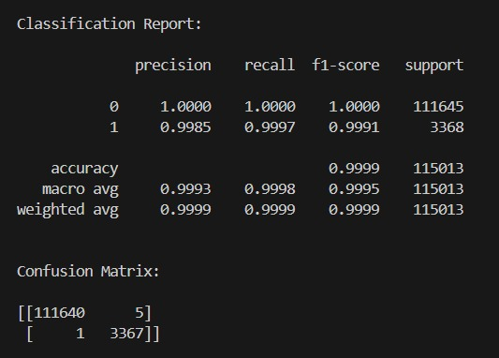
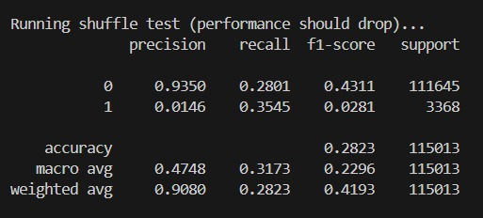
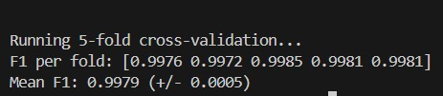

- SVM: Demonstrated strong baseline performance, achieving an anomaly precision of 0.9634, recall of 0.9994, and F1-score of 0.9811. However, it produced 128 false positives and missed 2 anomalies.
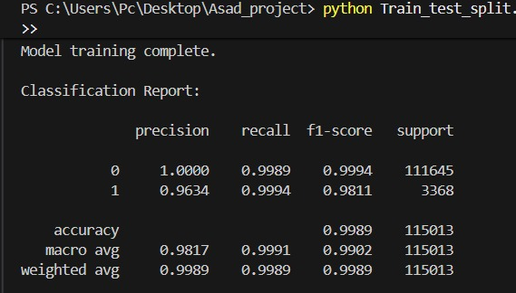
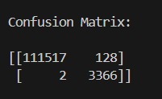
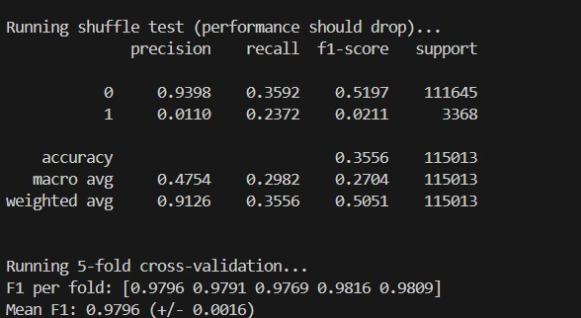

XGBoost distinctly outperformed SVM across all key parameters, highlighting its superior capacity to construct non-linear decision boundaries across complex event distributions.
2) Deep Learning (Supervised) Results:
The supervised Deep Learning pipeline evaluated sequence models capable of learning from log data without the rigid manual feature engineering required by traditional ML.
- LSTM: The Long Short-Term Memory network achieved an anomaly precision of 0.9808, a recall of 0.9988, and an F1-score of 0.9897. The model produced 66 false positives and missed 4 anomalies, while maintaining a perfect ROC-AUC of 1.0.
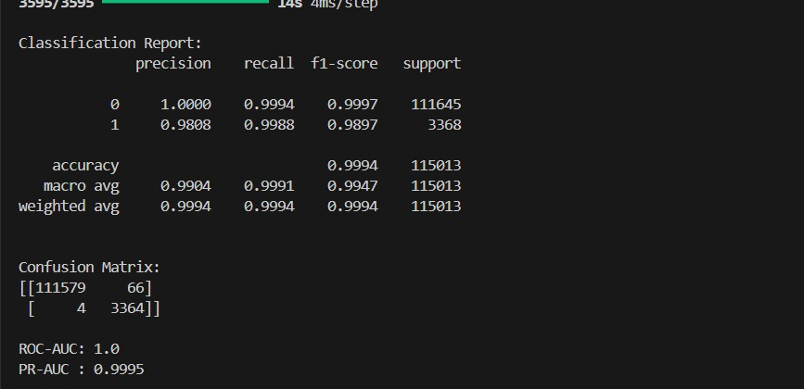
- GRU: The Gated Recurrent Unit performed comparably to the LSTM, achieving a precision of 0.9808, a recall of 0.9991, and an F1-score of 0.9899. It also produced 66 false positives but missed only 3 anomalies, similarly achieving an ROC-AUC of 1.0.
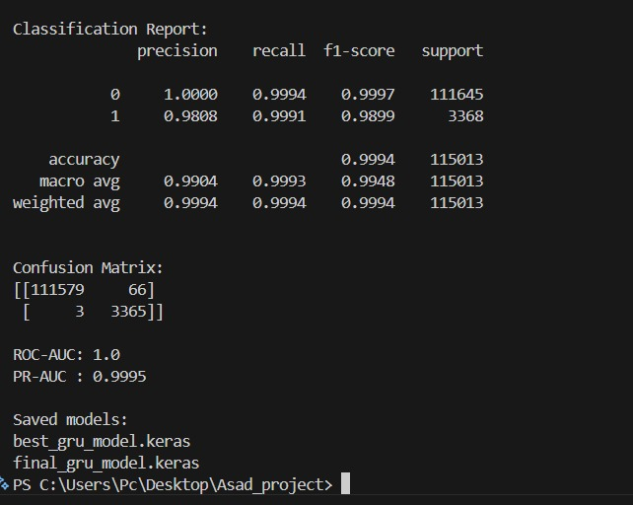
3) Generative AI Results:
The Generative AI models were trained exclusively on normal data sequences (normal-only), evaluating their capability to reconstruct logs and detect anomalies through reconstruction errors without relying on supervised anomaly labels.
- LSTM Autoencoder: Achieved an anomaly precision of 0.7232, a recall of 0.8818, and an F1-score of 0.7946. The model resulted in 1,137 false positives and 398 missed anomalies, with an ROC-AUC of 0.9964 and PR-AUC of 0.9049.
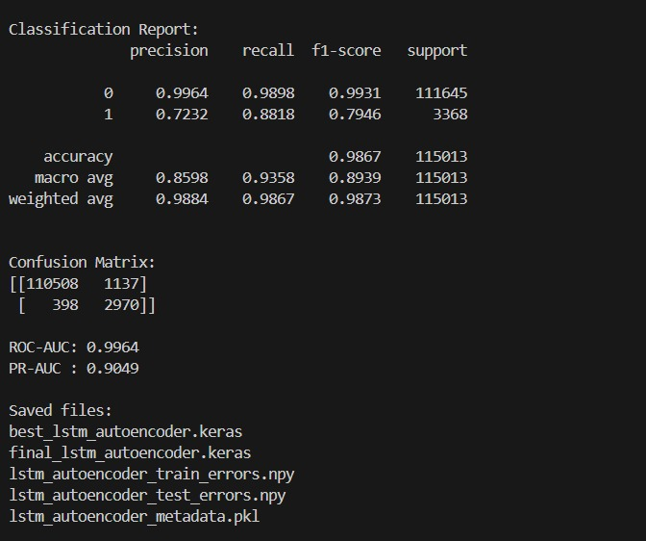
- LSTM-VAE: The Variational Autoencoder yielded an anomaly precision of 0.6944, a recall of 0.7429, and an F1-score of 0.7178. It generated 1,101 false positives and 866 missed anomalies, achieving an ROC-AUC of 0.9876 and PR-AUC of 0.7854.
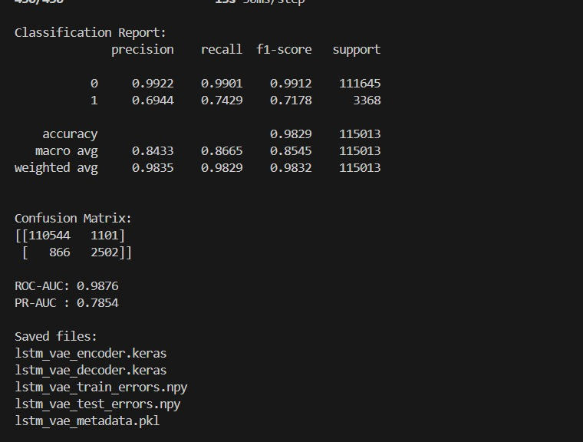
4) Comparative Analysis Synthesis (HDFS):
The benchmarking results present a clear trade-off between absolute accuracy and functional autonomy. While traditional supervised models like XGBoost achieve near-perfect F1-scores, they rely entirely on labeled training data and manual feature engineering (Event Count Matrices). The supervised Deep Learning sequence models (LSTM and GRU) successfully matched this high accuracy (F1-scores of ~0.99) while eliminating the need for rigid manual feature extraction, proving their efficacy at understanding sequential log patterns.
Conversely, the Generative AI models (LSTM Autoencoder and VAE) exhibit lower raw precision and recall metrics. However, these architectures operate under a fundamentally different, strictly unsupervised paradigm. Because they are trained exclusively on normal system behavior, their F1-scores (~0.71 - 0.79) represent a baseline capability for discovering unknown, zero-day anomalies without prior exposure to specific failure states. The high ROC-AUC scores for both generative models (>0.98) indicate that despite the lower precision thresholds, the underlying continuous reconstruction error distributions are highly separable.

Model | Type | Anomaly Precision | Anomaly Recall | Anomaly F1 | ROC-AUC | PR-AUC
XGBoost | Traditional ML | 99.85% | 99.97% | 99.91% | - | -
SVM | Traditional ML | 96.34% | 99.94% | 98.11% | - | -
LSTM | Supervised DL | 98.08% | 99.88% | 98.97% | 100.00% | 99.95%
GRU | Supervised DL | 98.08% | 99.91% | 98.99% | 100.00% | 99.95%
LSTM Autoencoder | Generative/ Normal-only | 72.32% | 88.18% | 79.46% | 99.64% | 90.49%
LSTM-VAE | Generative / Normal-only | 69.44% | 74.29% | 71.78% | 98.76% | 78.54%
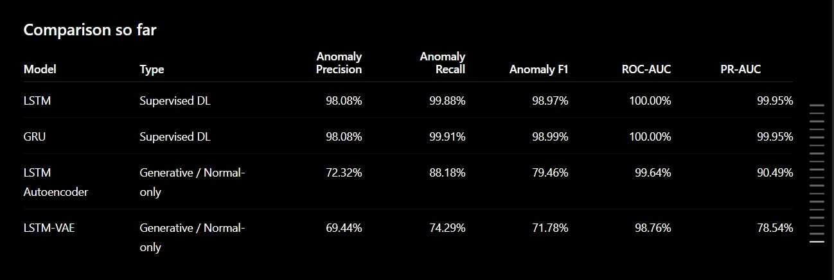B. Spark Logs Analysis
1) Machine Learning Results:
The traditional ML training logs show that Random Forest achieved a near-perfect ROC-AUC of 0.9902, vastly outperforming unsupervised methods like Isolation Forest (0.9559) and One-Class SVM (0.2388). However, despite the high ROC-AUC, the Isolation Forest model struggled with precision (0.04) and F1-score (0.04) for anomaly detection.
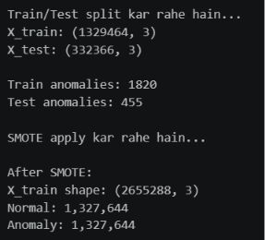

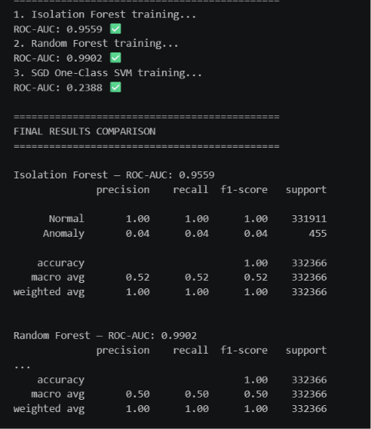

2) Deep Learning Results:
The LSTM Autoencoder model achieved a strong ROC-AUC score of 0.9822 and an excellent recall of 0.93 for anomalies. However, its precision was extremely low at 0.02, leading to an F1-score of just 0.05, indicating a high rate of false positives.
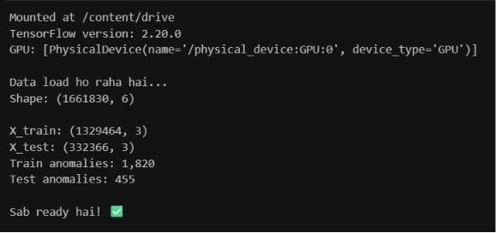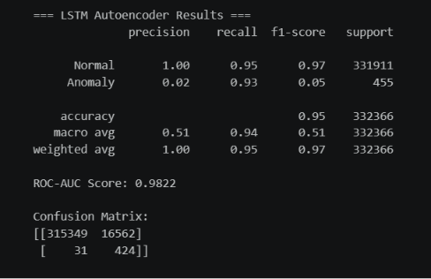
The CNN Classifier recorded the highest overall ROC-AUC for the Spark dataset at 0.9978, with a perfect recall of 1.00. Similar to the LSTM model, it suffered from severe precision issues (0.09), resulting in a low F1-score of 0.16.
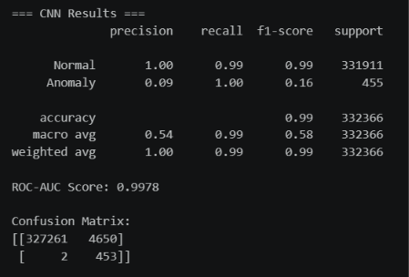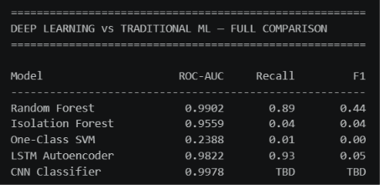
3) Generative AI Results:
Both generative models performed poorly on the Spark dataset. The Variational Autoencoder (VAE) achieved an ROC-AUC of 0.7700 but managed an F1-score of only 0.01, while the Generative Adversarial Network (GAN) failed to detect anomalies effectively, recording an ROC-AUC of 0.2479 and an F1-score of 0.01.
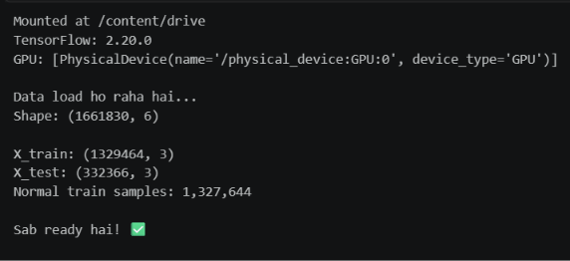
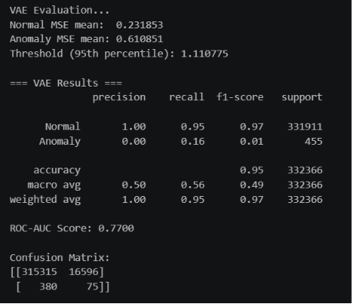
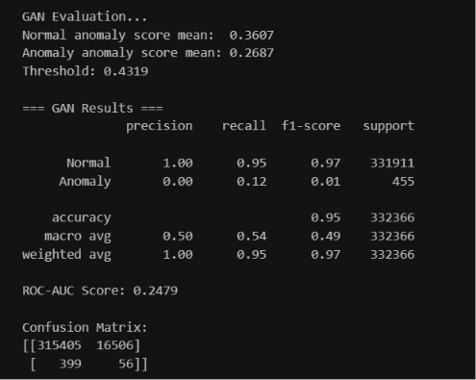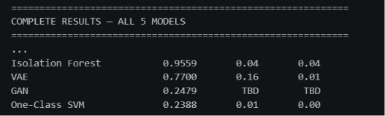
4) Spark Comparative Analysis Synthesis:
The comparative charts and confusion matrices visually reinforce that supervised learning (CNN and Random Forest) dominates in ROC-AUC. The confusion matrices clearly illustrate the high number of false positives generated by models like the LSTM Autoencoder (16,562 false positives) and VAE (16,596 false positives). The final table confirms that while Deep Learning and Machine Learning supervised models (CNN and Random Forest) yield the highest ROC-AUC and Recall, no model achieved a strong F1-score, with Random Forest peaking at just 0.44 due to widespread precision challenges across the dataset.
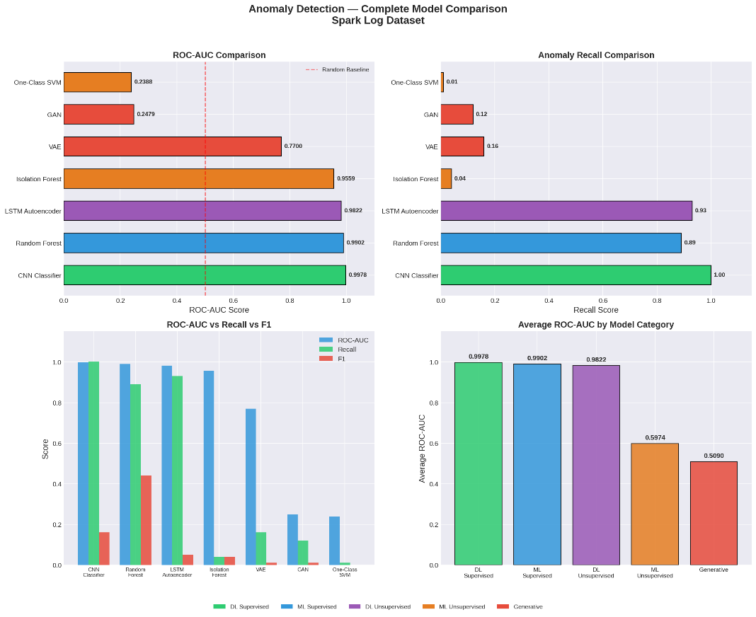
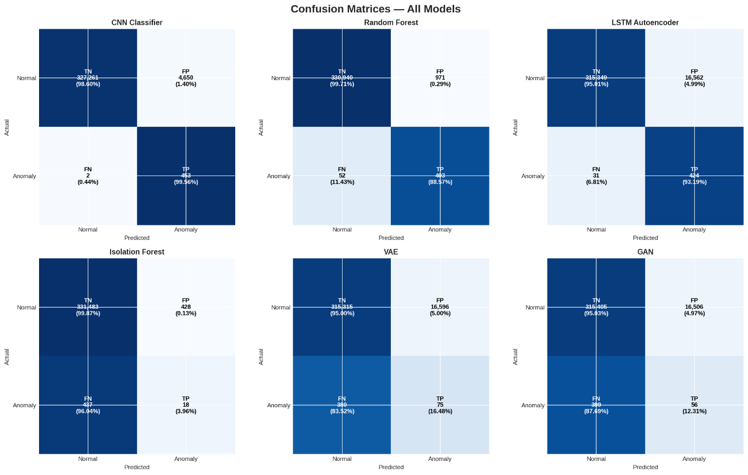
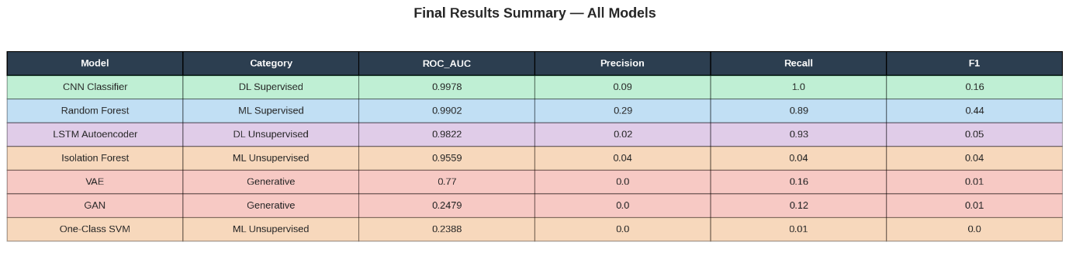

C. Hadoop Logs Analysis
1) Traditional Machine Learning Logs:
In the Hadoop environment, the Random Forest model achieved perfect metrics across the board, logging an ROC-AUC, Recall, and F1-score of 1.0000. Conversely, Isolation Forest and One-Class SVM performed poorly, with ROC-AUC scores of 0.2092 and 0.2383, respectively.
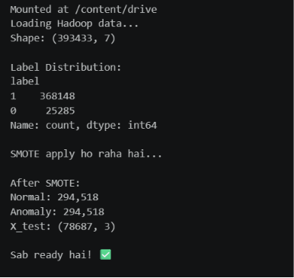
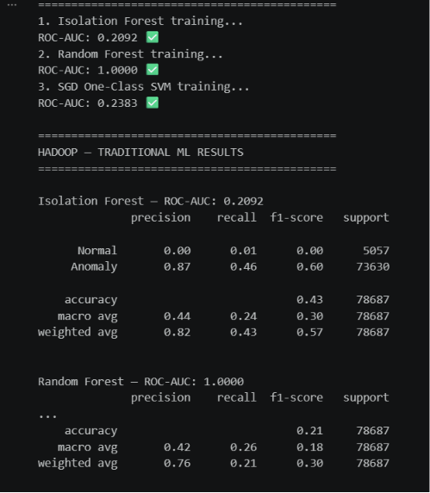
2) Deep Learning (LSTM and CNN):
Deep learning performance was mixed on the Hadoop data. The CNN Classifier performed exceptionally well with an ROC-AUC of 0.9617 and a strong F1-score of 0.91. The LSTM Autoencoder, however, saw a significant drop in performance compared to its Spark results, achieving an ROC-AUC of 0.6519 and an F1-score of 0.45.
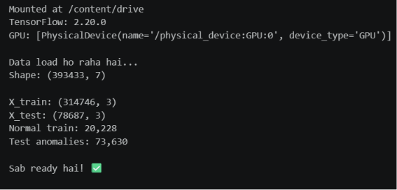
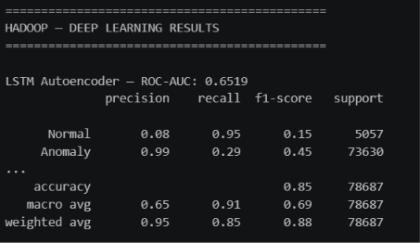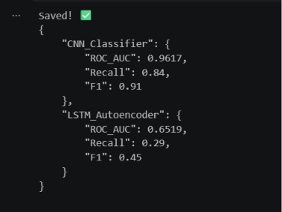

3) Generative AI (VAE and GAN):
Generative models continued to underperform on the Hadoop dataset. The GAN achieved an ROC-AUC of 0.6133 with an F1-score of 0.03, while the VAE recorded an ROC-AUC of 0.5235 and an F1-score of 0.12.
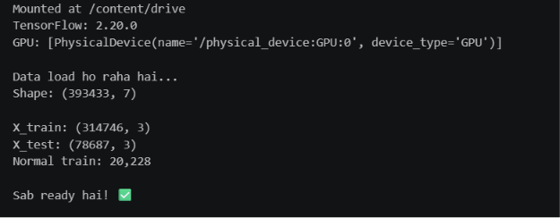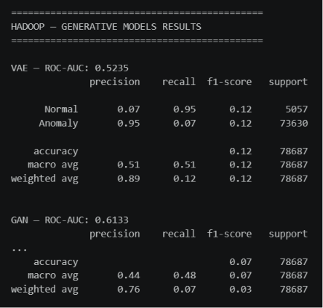

4) Hadoop Comparative Analysis Synthesis:
The summary table and confusion matrices for Hadoop confirm the absolute superiority of the Random Forest model, which recorded 0 false positives and 0 false negatives. The CNN also demonstrated high accuracy with only 50 false positives out of tens of thousands of records.
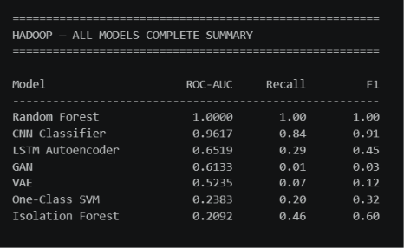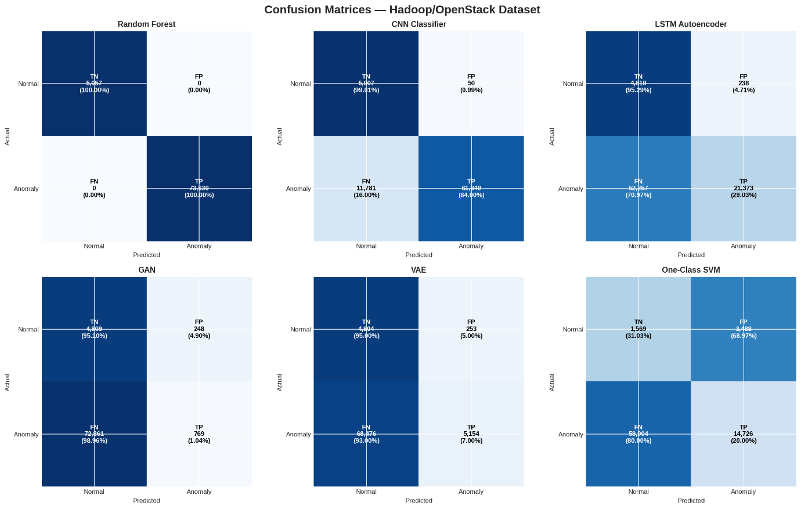

D. Overall Performance Synthesis (Spark vs. Hadoop)
The final heatmap provides a clear visual summary: Random Forest is the most consistently reliable model across both datasets, maintaining high ROC-AUC and the best relative F1-scores. CNN classifiers show excellent ROC-AUC but are highly susceptible to F1-score degradation depending on the dataset (0.16 on Spark vs. 0.91 on Hadoop), while Generative and Traditional Unsupervised models exhibit consistently weak performance across both environments.

Model | Category | HDFS F1 | Spark F1 | Hadoop F1
XGBoost | Traditional ML (Supervised) | 0.9991 | - | -
SVM | Traditional ML (Supervised) | 0.9811 | - | -
Random Forest | Traditional ML (Supervised) | - | 0.44 | 1
LSTM | Deep Learning (Supervised) | 0.9897 | - | -
GRU | Deep Learning (Supervised) | 0.9899 | - | -
CNN Classifier | Deep Learning (Supervised) | - | 0.16 | 0.91
Isolation Forest | Traditional ML (Unsupervised) | - | 0.04 | 0.6
One-Class SVM | Traditional ML (Unsupervised) | - | 0 | 0.32
LSTM Autoencoder | Generative / Unsupervised DL | 0.7946 | 0.05 | 0.45
VAE / LSTM-VAE | Generative | 0.7178 | 0.01 | 0.12
GAN | Generative | - | 0.01 | 0.03
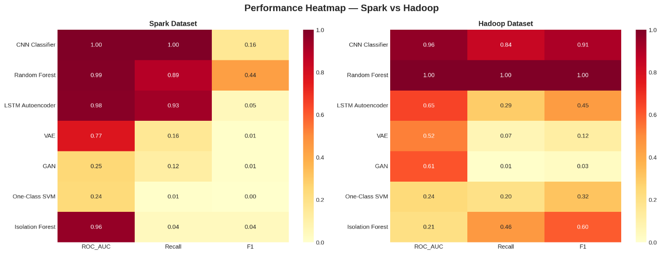
Key Takeaways from the Data:
- The HDFS Illusion: Almost everything performed exceptionally well on HDFS, making it seem like the problem of anomaly detection was solved.
- The Spark Reality Check: Spark completely broke the models. The complex, overlapping nature of Spark execution logs created a massive false-positive problem, dragging almost every model's F1-score below 0.50.
- The Generative Struggle: While Generative AI (LSTM Autoencoder, VAE, GAN) is theoretically great because it doesn't need manual feature engineering, it consistently struggled with noise across all environments, peaking at just 0.7946 on the "easy" HDFS dataset and failing entirely on Spark and Hadoop.
Chapter 5: Conclusion & Future Work
5.1 Conclusion
This thesis presented a comprehensive comparative study evaluating Traditional Machine Learning (ML), Deep Learning (DL), and Generative AI models for automated log anomaly detection across three heterogeneous environments: HDFS, Apache Spark, and Hadoop.
The empirical findings reveal a distinct trade-off between absolute accuracy and functional autonomy. Traditional supervised classifiers (like XGBoost and Random Forest) achieve near-perfect F1-scores on highly balanced or structurally consistent datasets like HDFS and Hadoop, but they remain fundamentally brittle and heavily dependent on labor-intensive, manual feature engineering. Supervised Deep Learning architectures (such as CNNs, LSTMs, and GRUs) successfully eliminate the need for rigid manual feature extraction while maintaining strong performance, yet they demonstrate severe volatility and performance degradation when confronted with the high noise levels and complex concurrency patterns inherent to Spark execution logs.
Conversely, Generative AI models (such as the LSTM Autoencoder, VAE, and GAN) operating under a strictly unsupervised, normal-only paradigm exhibit lower raw precision and F1-scores across the board. However, their consistently high ROC-AUC scores demonstrate that the underlying reconstruction error distributions remain highly separable. Ultimately, while supervised models dominate under closed-world assumptions, generative architectures establish a vital baseline capability for discovering unknown, zero-day anomalies without requiring prior exposure to production failure states.
5.2 Future Work
To address the limitations identified in this comparative framework, future research will focus on the following directions:
- Dynamic Thresholding Mechanisms: Implementing adaptive or extreme value theory (EVT) thresholding to replace static percentile cutoffs, thereby minimizing the high false-positive rates observed in generative models on complex datasets like Spark.
- Concept Drift Mitigation: Investigating online incremental learning and fine-tuning paradigms to ensure deep generative models remain robust as log formats evolve over time alongside software updates.
- Fine-Grained Parameter Classification: Extending the semantic capabilities of raw log embeddings to parse and categorize specific variable fields (such as status codes, IP addresses, and block IDs) rather than relying solely on event sequence IDs.
- Hybrid Neuro-Symbolic Frameworks: Designing unified frameworks that combine the statistical robustness of traditional ensemble methods with the unsupervised flexibility of generative sequence modeling.
References
[1] Zhu, J., He, S., He, P., Liu, J., & Lyu, M. R. (2023). "Loghub: A Large Collection of System Log Datasets for AI-driven Log Analytics." In Proceedings of the 2023 IEEE 34th International Symposium on Software Reliability Engineering (ISSRE), pp. 355-366.
[2] Khan, M. A. M. (2026). "Generative Models vs Traditional AI-Driven Anomaly Detection in Large-Scale System Logs – A Comparative Study." Master's Thesis, Air University, Department of Computer Science (MSAI Program). Referenced from the source working file: "final thesis report asad msai 4 23-6-2026.docx".
[3] He, P., Zhu, J., Zheng, Z., & Lyu, M. R. (2017). "Drain: An online log parsing approach with fixed depth tree." In Proceedings of the 2017 IEEE International Conference on Web Services (ICWS), pp. 33-40.
[4] Du, M., Li, F., Zheng, G., & Srikumar, V. (2017). "DeepLog: Anomaly detection and diagnosis from system logs through deep learning." In Proceedings of the 2017 ACM SIGSAC Conference on Computer and Communications Security, pp. 1285-1298.
[5] Zhang, X., Xu, Y., Qin, S., He, S., Biao, Q., Li, Z., ... & Zhang, D. (2021). "Onion: Identifying incident-indicating logs for cloud systems." In Proceedings of the 29th ACM Joint Meeting on European Software Engineering Conference and Symposium on the Foundations of Software Engineering (ESEC/FSE), pp. 1253-1263.
[6] Xu, W., Huang, L., Fox, A., Patterson, D. A., & Jordan, M. I. (2009). "Detecting large-scale system problems by mining console logs." In Proceedings of the ACM SIGOPS 22nd Symposium on Operating Systems Principles (SOSP), pp. 117-132.
[7] Liu, F. T., Ting, K. M., & Zhou, Z. H. (2008). "Isolation forest." In Proceedings of the 8th IEEE International Conference on Data Mining (ICDM), pp. 413-422.
[8] Lin, Q., Zhang, H., Lou, J. G., Zhang, Y., & Chen, X. (2016). "Log clustering based problem identification for online service systems." In Proceedings of the 38th International Conference on Software Engineering Companion (ICSE-C), pp. 102-111.

